University of Science and Technology
- Wrocław-



LABORATORY 7: UTILIZING SOFTWARE TO SCHEDULE AN IT PROJECT

SUPPORT FOR IT PROJECT MANAGEMENT
2025/2026
Teacher: Piotr Zabawa
Student: Álvaro Puebla Ruisánchez 293867

Table of Contents
Table of Contents 2
1. Software Overview 3
1.1 Name and Purpose 3
1.2 Key Functionality 3
1.3 Why ClickUp Was Selected 3
2. Performed Tasks 4
2.1 Task 1 - Registration and Initial Setup of ClickUp 4
2.2 Task 2 - Creating the Project Schedule with Tasks, Dependencies, and Milestones 5
2.3 Task 3 - Updating Task Statuses and Reviewing the Gantt Chart 6
3. Summary 7
3.1 Software Suitability Assessment 7
3.2 Evaluation of Software Functionality 7
3.3 User Interface Evaluation 7
3.4 Evaluation of Other Software Attributes 7

1. Software Overview

1.1 Name and Purpose
The software selected for use during this laboratory session is ClickUp, a cloud-based project management and task-scheduling platform developed by ClickUp Inc. ClickUp is designed to serve as an all-in-one productivity tool that enables teams to plan, track, and collaborate on projects of varying complexity. Its core purpose within the context of IT project management is to provide a centralized environment where project schedules can be constructed, visualized, and continuously updated throughout the project lifecycle.
In the specific context of this laboratory exercise, ClickUp was employed to model and schedule the development of a small online store. This scenario required the definition of tasks, the establishment of inter-task dependencies, the identification of key project milestones, and the monitoring of individual task progress - all of which ClickUp readily supports.

1.2 Key Functionality
ClickUp offers a comprehensive set of features relevant to IT project scheduling and requirements management. The most pertinent functionalities utilized or evaluated during this exercise include:
- Gantt Chart View: Provides a visual timeline of all project tasks, enabling users to inspect scheduling, overlaps, and the overall project duration at a glance.
- Task Dependencies: Allows tasks to be linked so that one task cannot begin until a predecessor is completed, thereby enforcing a logical execution order and preventing scheduling conflicts.
- Milestones: Supports the designation of specific tasks as milestones, representing major project deliverables or key decision points along the project timeline.
- Task Status Tracking: Enables each task to be assigned a status such as "To Do", "In Progress", or "Complete", giving the project manager real-time visibility into execution progress.
- Team Assignment: Facilitates the allocation of tasks to individual team members, clarifying responsibilities and enabling workload management.
- Calendar View: Offers an alternative date-based perspective of the schedule, useful for deadline review.
- Notifications and Reminders: Alerts team members to upcoming deadlines or changes in task status.
- Comments and Collaboration: Enables in-context communication on individual tasks, reducing the need for external messaging tools.
- PDF/Excel Export: Supports the generation of formal reports for stakeholder communication (available in paid tiers).
- Cloud-Based Access: The platform is entirely browser-based, requiring no local installation and supporting access from any device.

1.3 Why ClickUp Was Selected
A structured evaluation was conducted across five candidate tools: Microsoft Project, ClickUp, Trello, Asana, and Primavera P6. The selection was based on a functional requirements specification that identified eleven key scheduling features, prioritized using the MoSCoW method (Must Have, Should Have, Could Have, Won't Have).
ClickUp emerged as the optimal choice for the following reasons:
- Best balance of features and simplicity: ClickUp provides native Gantt chart support, task dependencies, milestones, and progress tracking - all identified as "Must Have" requirements - within its free tier (including a 60-use trial of the Gantt view).
- No installation required: As a web application, ClickUp is immediately accessible via any modern browser, eliminating setup overhead during a laboratory session.
- No external power-ups needed: Unlike Trello, which requires third-party add-ons for most advanced scheduling features, ClickUp integrates these capabilities natively.
- Free tier sufficiency: The free plan provides enough functionality for the scope of this exercise, covering task dependencies, milestones, calendar view, team comments, and basic progress tracking.
- Cost advantage over alternatives: Microsoft Project ($10-$55/user/month or $720-$1,410 as a one-time purchase) and Primavera P6 ($3,520/user) were ruled out due to cost. Asana's timeline features are significantly restricted in its free plan.
In summary, ClickUp provided the most complete coverage of the defined functional requirements within an accessible, cost-free format, making it the most appropriate tool for this academic scheduling exercise.

2. Performed Tasks

2.1 Task 1 - Registration and Initial Setup of ClickUp
Task description:
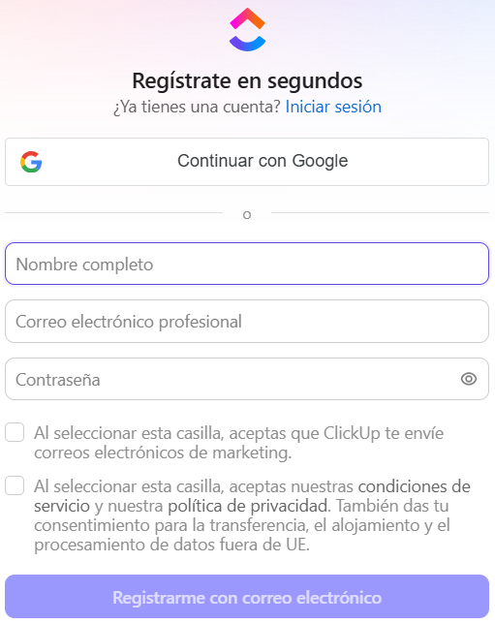
The first step involved creating a ClickUp account and configuring the initial project workspace. The ClickUp website (clickup.com) was accessed via a web browser, and the registration process was completed using a student Google account. This method leveraged Google OAuth to streamline account creation without requiring a separate password. [Figure 1]
Figure 1. ClickUp sign-up page with Google account authentication prompt.
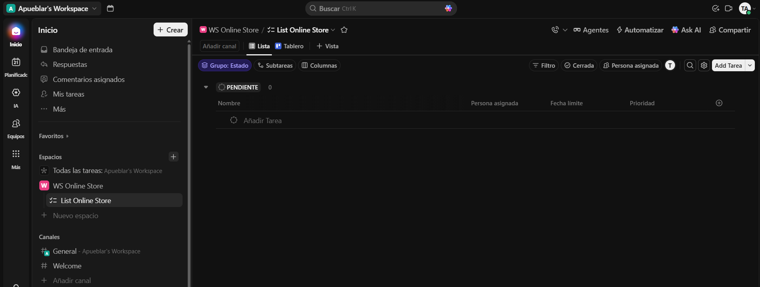
Following successful authentication, ClickUp's onboarding wizard was used to set up a new workspace. Within the workspace, a dedicated Space was created to contain the project, and a new List was established as the primary container for the task backlog. This hierarchical structure - Workspace → Space → List - reflects ClickUp's organizational model and provides the foundation upon which all subsequent scheduling activities were performed. [Figure 2]
Figure 2. Newly created workspace with an empty task list ready for the online store project.

2.2 Task 2 - Creating the Project Schedule with Tasks, Dependencies, and Milestones
Task description:
With the workspace configured, the core scheduling activity was performed. The exercise scenario required modelling the development schedule of a small online store. A minimum of eight tasks were created, each representing a discrete phase or deliverable in the development process. The tasks defined were:
- Requirements Gathering - Definition of functional and non-functional requirements with the client.
- UI/UX Design - Creation of wireframes and visual mockups for the store's user interface.
- Database Design - Design of the data model for products, users, and orders.
- Backend Development - Implementation of server-side logic, APIs, and business rules.
- Frontend Development - Development of the client-facing web interface.
- Payment Gateway Integration - Integration of an external payment processing service.
- Testing and Quality Assurance - Functional, performance, and security testing of the application.
- Deployment and Launch - Delivery of the application to the production environment.
For each task, a start date, due date, and assignee were specified. Two task dependencies were then configured:
- Frontend Development was set as dependent on UI/UX Design, ensuring that frontend implementation only begins once design deliverables are finalized.
- Testing and Quality Assurance was set as dependent on both Backend Development and Frontend Development, enforcing that testing cannot commence until both implementation streams are complete.
Additionally, two milestones were defined to mark the major project goals:
- Milestone 1: Design Approval - Placed after the completion of UI/UX Design, marking the point at which the client approves the visual direction of the project.
- Milestone 2: Product Launch - Placed at the end of the project timeline, representing the successful delivery and deployment of the online store.
You can see the results on [Figure 3] and on [Figure 4].
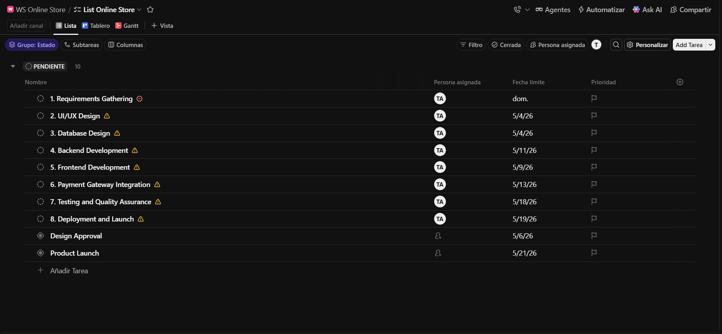
Figure 3. ClickUp task list view showing all eight tasks and 2 milestones with assigned dates and team members.
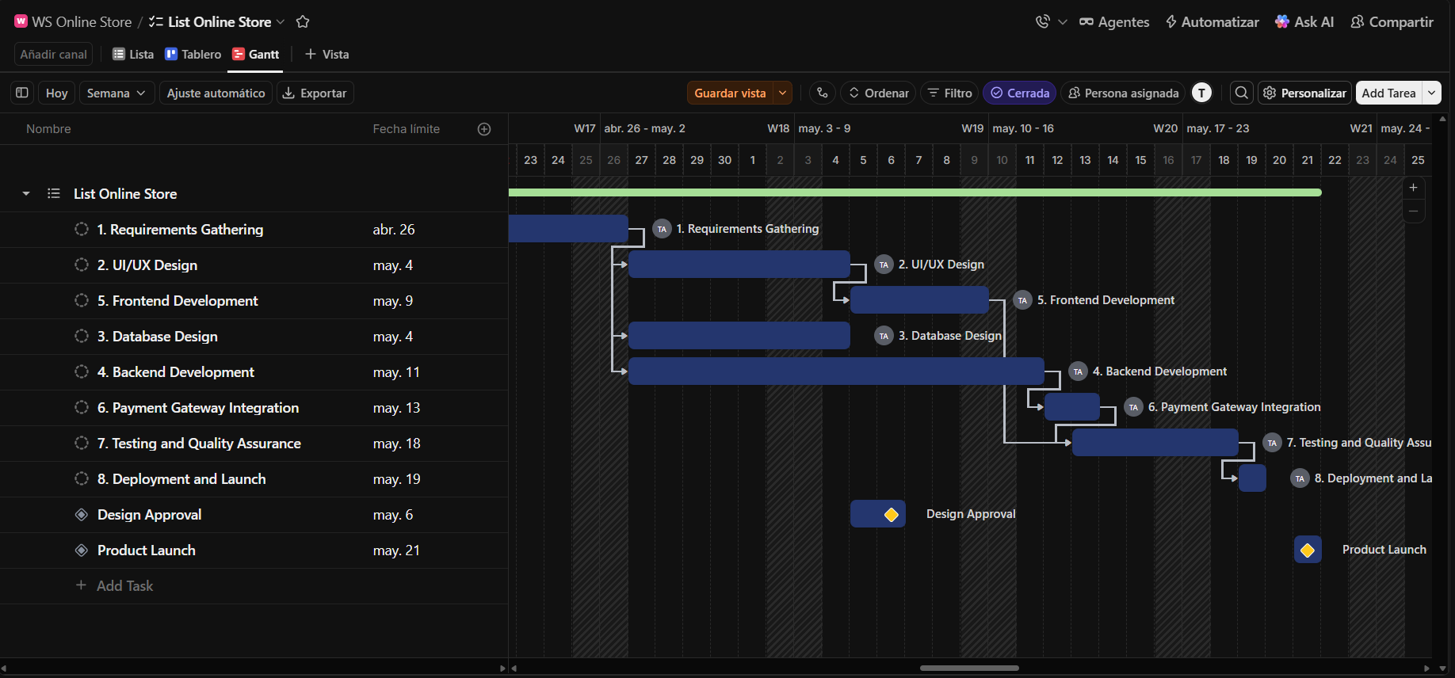
Figure 4. Gantt Chart view displaying task timeline, dependencies (arrows between tasks), and milestones.

2.3 Task 3 - Updating Task Statuses and Reviewing the Gantt Chart
Task description:
In the final phase of the exercise, task statuses were updated to reflect simulated project progress. This task demonstrated ClickUp's progress monitoring functionality and illustrated how the Gantt chart view responds dynamically to status changes.
The following status updates were applied:
- Requirements Gathering → set to Complete, indicating that this phase had been fully delivered.
- UI/UX Design → set to Complete, triggering the availability of Frontend Development according to the configured dependency.
- Database Design → set to In Progress, indicating that this phase was actively underway.
- Backend Development → set to In Progress, reflecting simultaneous execution alongside database design.
- All remaining tasks (Frontend Development, Payment Gateway Integration, Testing and QA, Deployment) retained their initial To Do status.
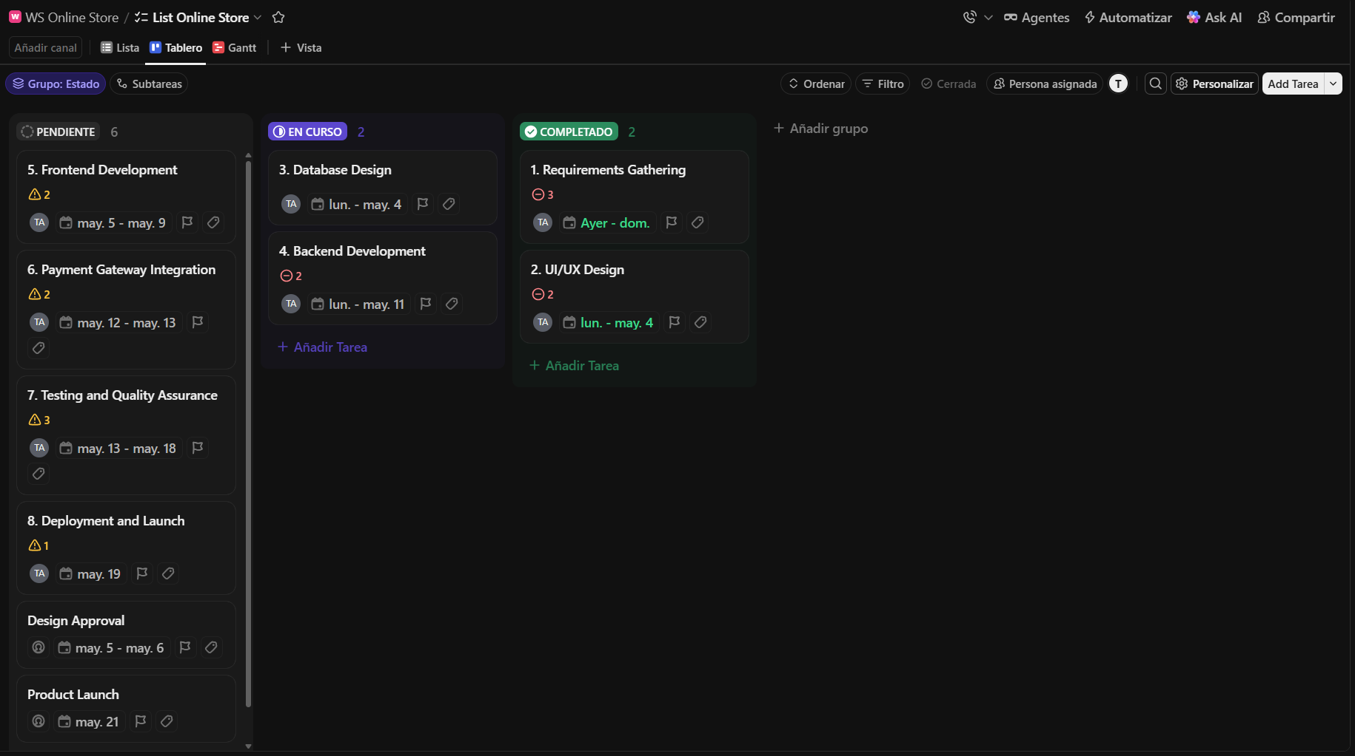
After applying these updates [Figure 5], the Gantt chart was reviewed [Figure 6] to confirm that the visual representation accurately reflected the defined schedule, dependency chain, and current progress. The milestone markers were visible in the chart and correctly positioned relative to the tasks they depended upon.
Figure 5. Board showing updated statuses (Complete, In Progress, To Do) across all project tasks.
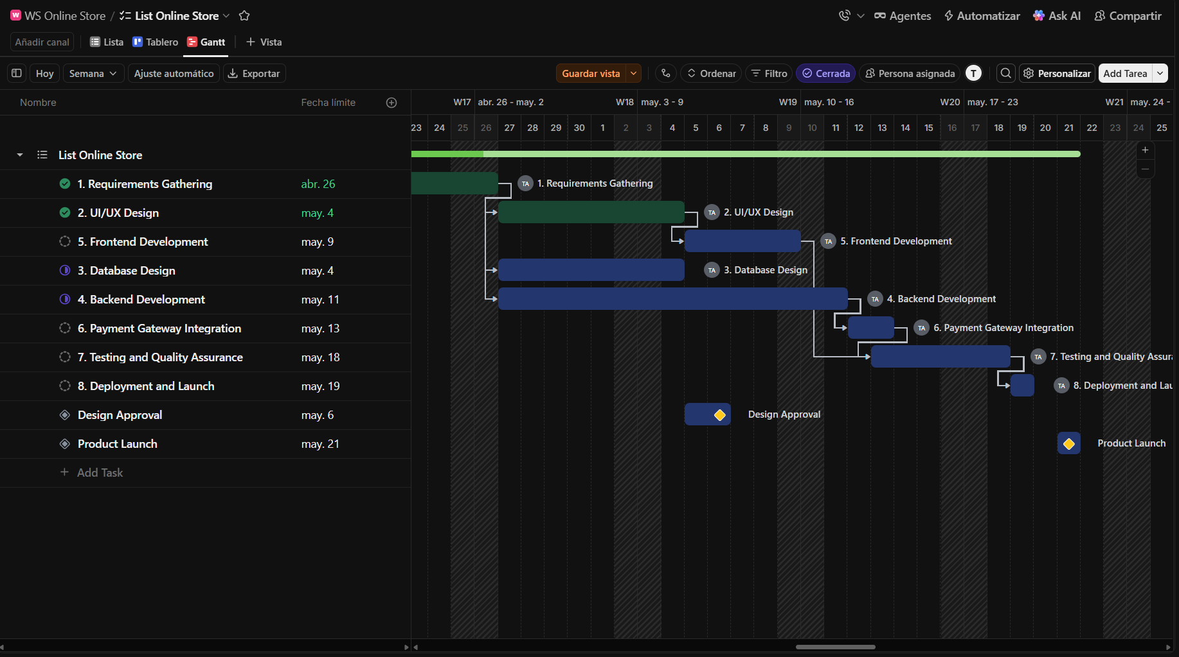
Figure 6. Gantt Chart view after status updates, showing progress bars and milestone markers.

3. Summary

3.1 Software Suitability Assessment
ClickUp is well suited for requirements management and project scheduling tasks at the scale encountered in this laboratory exercise. It covers all "Must Have" functional requirements identified during the tool selection phase: Gantt chart visualization, task dependencies, milestone tracking, team assignment, and progress monitoring. For small-to-medium IT projects involving a development team of up to ten members, ClickUp's free tier provides sufficient capability to support the full scheduling lifecycle - from initial task definition through execution monitoring. For larger enterprise projects requiring advanced resource levelling, critical path analysis, or integration with ERP systems, a dedicated tool such as Microsoft Project or Primavera P6 would be more appropriate.

3.2 Evaluation of Software Functionality
The functionalities offered by ClickUp are broad and cover the most common needs of an IT project manager. The Gantt chart provides an accurate and visually clear representation of the project timeline and is responsive to status changes and dependency configurations. Task dependency management works reliably within the free tier and enforces correct sequencing. Milestone markers are visually distinct and easy to identify within the Gantt view. One notable limitation is that the Gantt chart view is offered as a 60-use trial in the free plan, after which a paid subscription is required to continue using it. Similarly, PDF and Excel export, dashboard reports, and advanced notification integrations (e.g., Google Calendar sync) are restricted to paid tiers. Despite these limitations, the available free functionality is sufficient for academic and small-team use.

3.3 User Interface Evaluation
ClickUp's user interface is modern, responsive, and well-organized. The platform presents a consistent visual language across its various views (List, Board, Gantt, Calendar), which facilitates navigation between different perspectives of the same project data. The onboarding experience is guided and requires no prior knowledge of project management software, making it accessible to students and new users. Task creation is intuitive, with clear fields for name, assignee, dates, and status. Dependency configuration, while functional, requires some exploration to locate, as it is accessed through the task details panel rather than directly from the Gantt view. Overall, the interface strikes a good balance between feature richness and usability, though it can feel slightly cluttered for users who only need basic scheduling functionality.

3.4 Evaluation of Other Software Attributes
- Performance: ClickUp performs well in a browser environment. Page load times and transitions between views are fast under normal network conditions, with no observable lag during the exercise.
- Accessibility: The platform is entirely cloud-based, meaning it can be accessed from any device with a modern browser and an internet connection. No installation or administrative privileges are required, which is advantageous in a university lab environment.
- Collaboration: Real-time collaboration is supported, with multiple users able to view and edit the same project simultaneously. Comments on individual tasks facilitate asynchronous communication without leaving the platform.
- Learning Curve: ClickUp's learning curve is relatively shallow for basic project scheduling tasks. More advanced features (automations, custom fields, dashboards) require additional exploration but are not necessary for foundational use.
- Limitations: The primary limitation for academic use is the paywall on the Gantt chart after 60 views, along with export restrictions. Additionally, the free plan limits certain team size features and does not provide guest access without a paid plan. These constraints are manageable for a single laboratory session but would become significant obstacles in longer-term or larger-scale project environments.

